How to shop online using flipkart website

Table of Contents
About Flipkart 3
Getting started 3
Searching for products 4
Groceries……………………………………………………………………………………………………………………………………………6
FAQ……………………………………………………………………………………………………………………………………………………7
Conclusion…………………………………………………………………………………………………………………………………………8

About Flipkart
Flipkart is an online shopping for all your product categories such as consumer electronics, fashion, home essentials, groceries, and lifestyle products.
This user guide includes the information you need to make purchase in Flipkart’s website. It contains detailed information about the following:

- How to login in Flipkart.
- How to search for your products
- How to pay for your selected products
- How to place order if product is in cart
- How to place order for groceries
- FAQ
- How to view recently viewed products
- Conclusion

Getting started

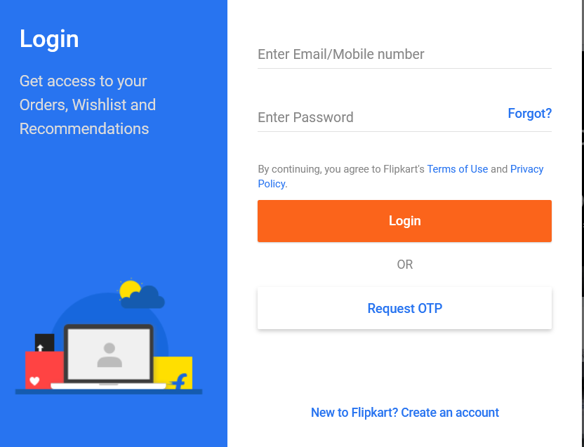

As a first-time user, you need to register in Flipkart website or Flipkart app. The following steps required to register as a user:

- Click Login.
- Enter your mobile number or Email ID.
- Enter your generated OTP.
- Click verify.

You are logged in as a registered user.

Once you are a registered user, you can login using your email address or mobile number that you have provided at the time of registration along with the password provided for registering your profile.

Searching for products
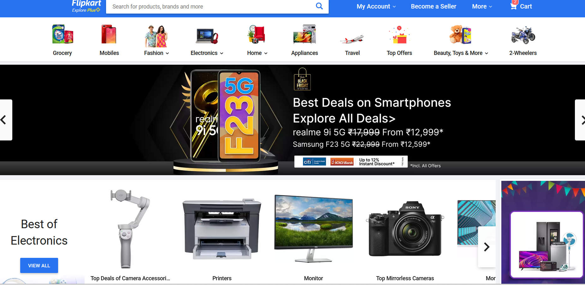

Search for any products you want to purchase
- Type for your product in the search box.
- The screen displays a list of related products.
- Click on your choice.
- Click on BUY NOW.

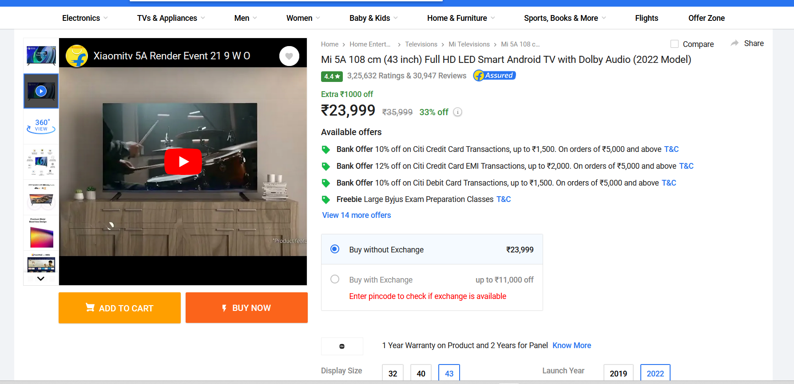

- Enter your address details.
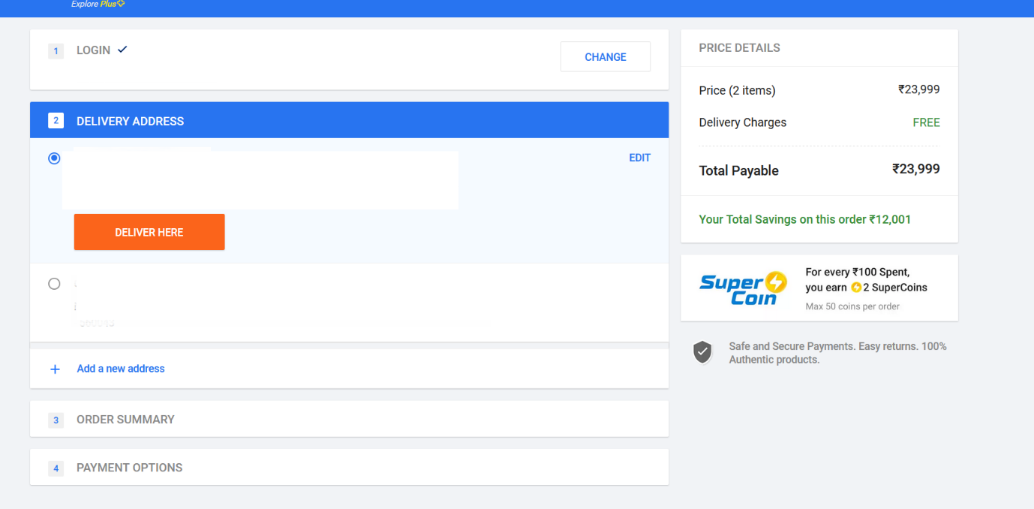

- Your order summary displays:
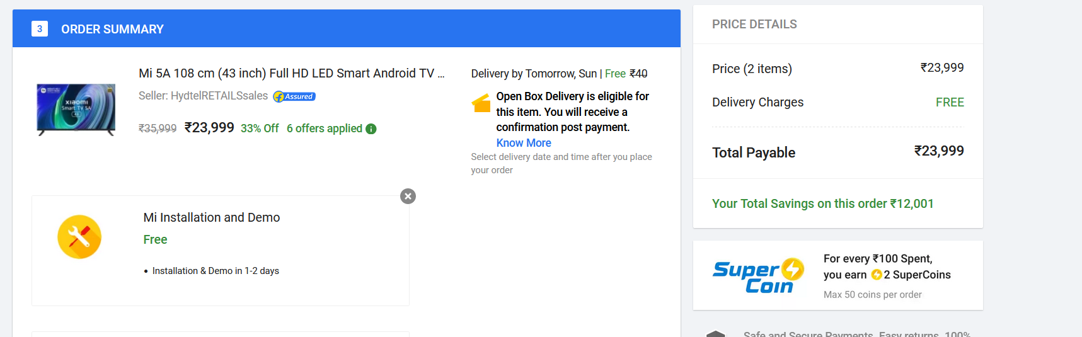

- Enter your payment details if you are buying this product only now.
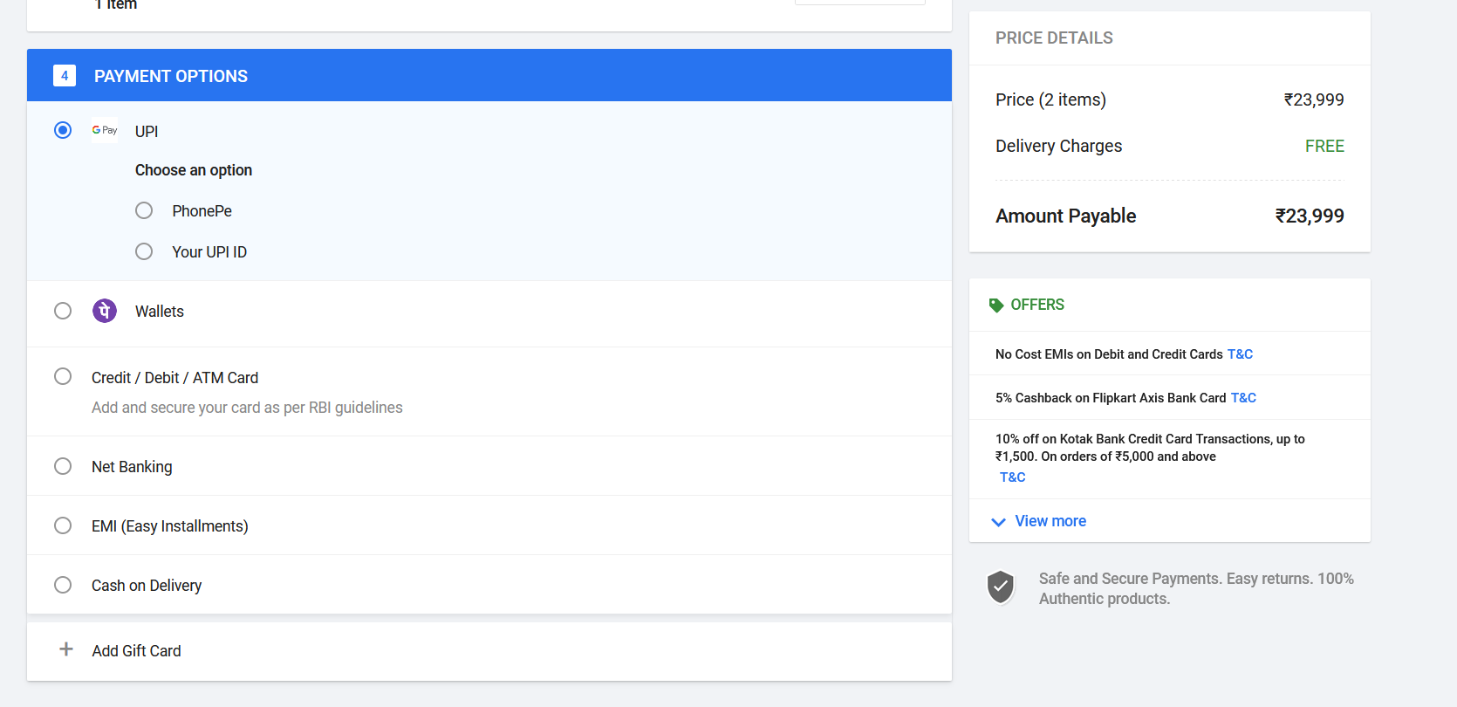
Enter your payment details such as UPI, Wallets, Credit/ Debit/ ATM Card, Net banking.

- Click on CONTINUE.
- Click on PAY NOW.
You have placed the order for your product successfully.

Items in the cart
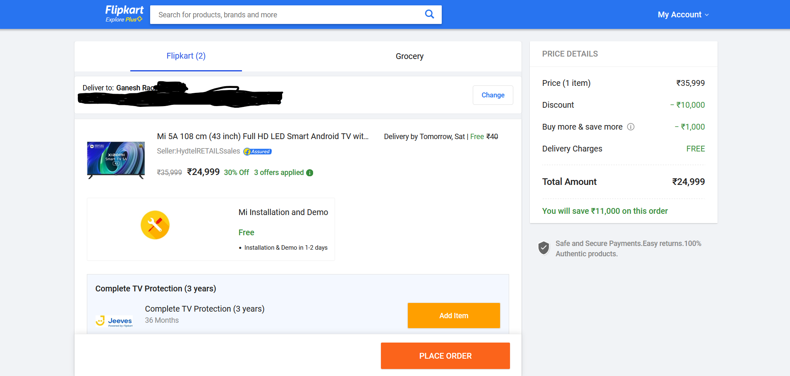
1.If you have added the product in the cart but not yet paid then it will be in cart. If there is more than one product that the user wants to purchase, please follow the steps from 7 in the previous topic.

Click PLACE ORDER to purchase the product that is selected in the cart.

Groceries
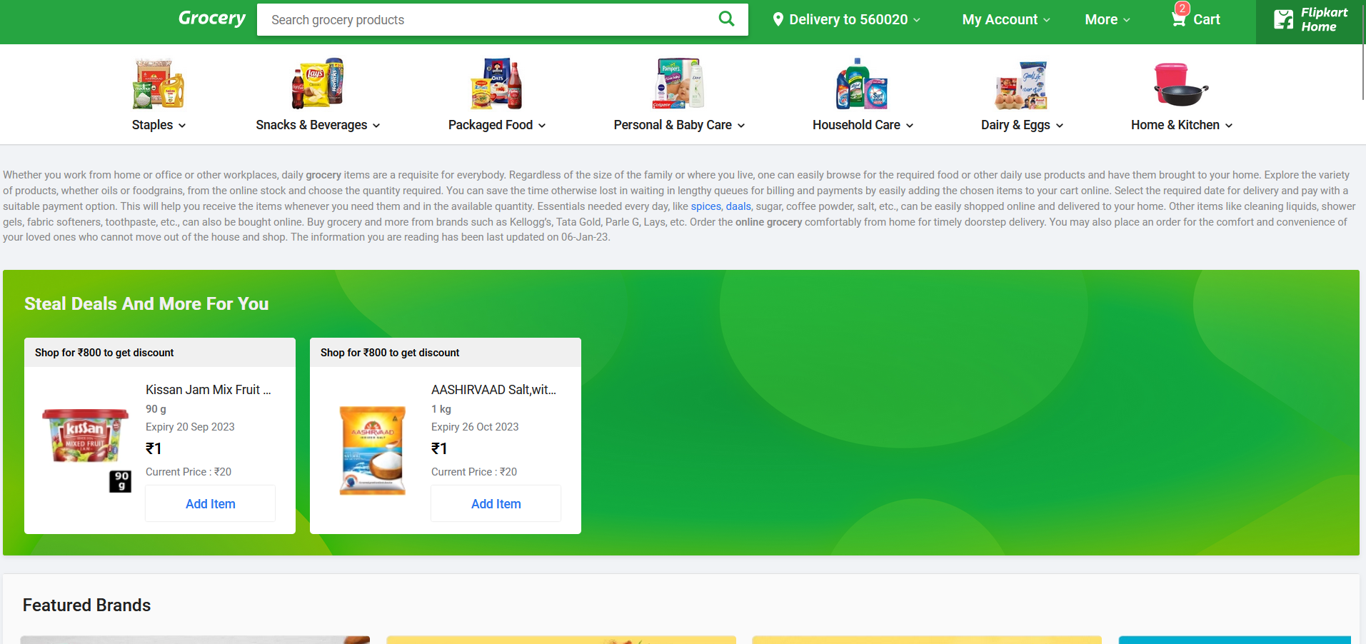
1.If you want to place orders from grocery store, click on the categories or search for groceries in search text box. Now follow steps from 7 to purchase the groceries that you have selected from the searching for products topic.

FAQ
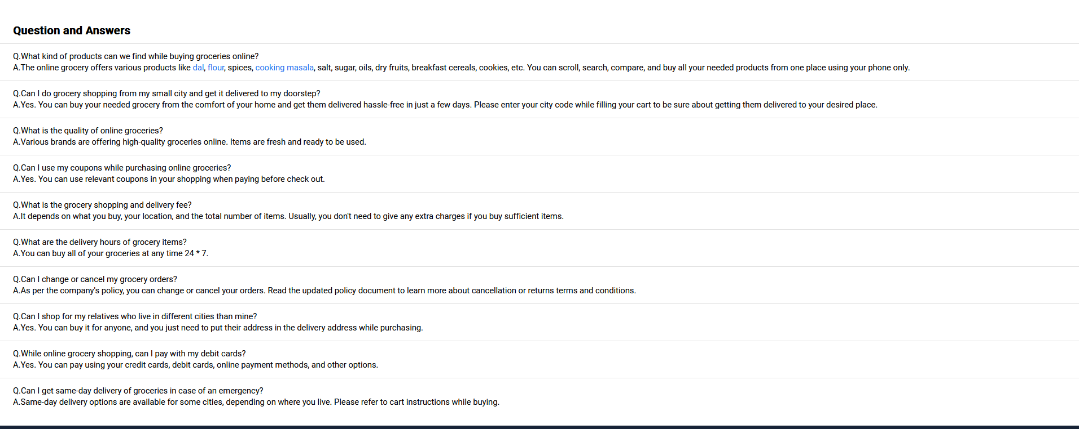
- If the customer has any doubts or clarification to be cleared before ordering the products can be seen above.

Recently Viewed Section
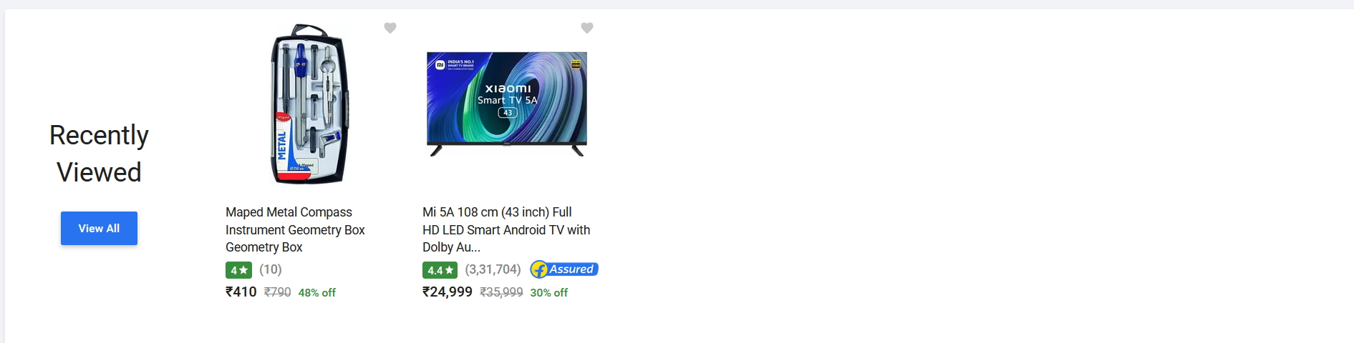

1.There is an option for recently viewed section. This will display the products that was recently viewed by the customer.

Conclusion
After extensive research and analysis, we have drawn to the following conclusions:

- Yes, online shopping is pretty popular among the young Indian blood.
- Many teenagers and bachelors are now using the E-Commerce for fulfilling their shopping desires.
- Most of them are completely aware of all the pros and cons of online shopping.
- Graduates are the majority users of E-retail. Cash on delivery remains the best choice for payment followed by Debit and credit cards.
- Females are marginally more interested in shopping through the internet due to its convenience.
- Most users are shopping once or twice a week though the web with spending ranging from rupees 100 to 2500 monthly. With most of the E- retailers selling branded goods and having flexible return policies, they are being well trusted by the users.
- Apparel, footwear and Accessories lead as the most demanded goods online followed by software and music. The most visited and trusted sites are Amazon and Flip-kart according to the survey.
- After this analysis we conclude that India has a huge potential for growth of a multibillion-dollar industry of E-Commerce as the top players of the market are having more than 100% growth year on year and their valuations are crossing billions of dollars.

